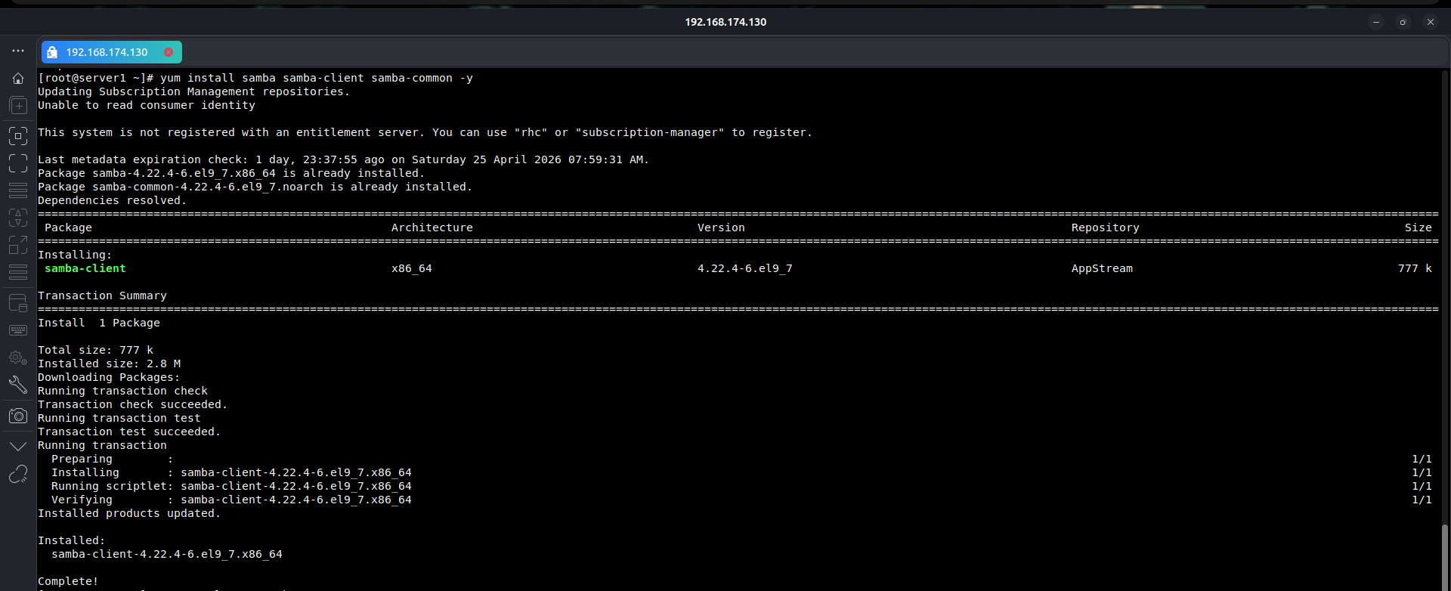
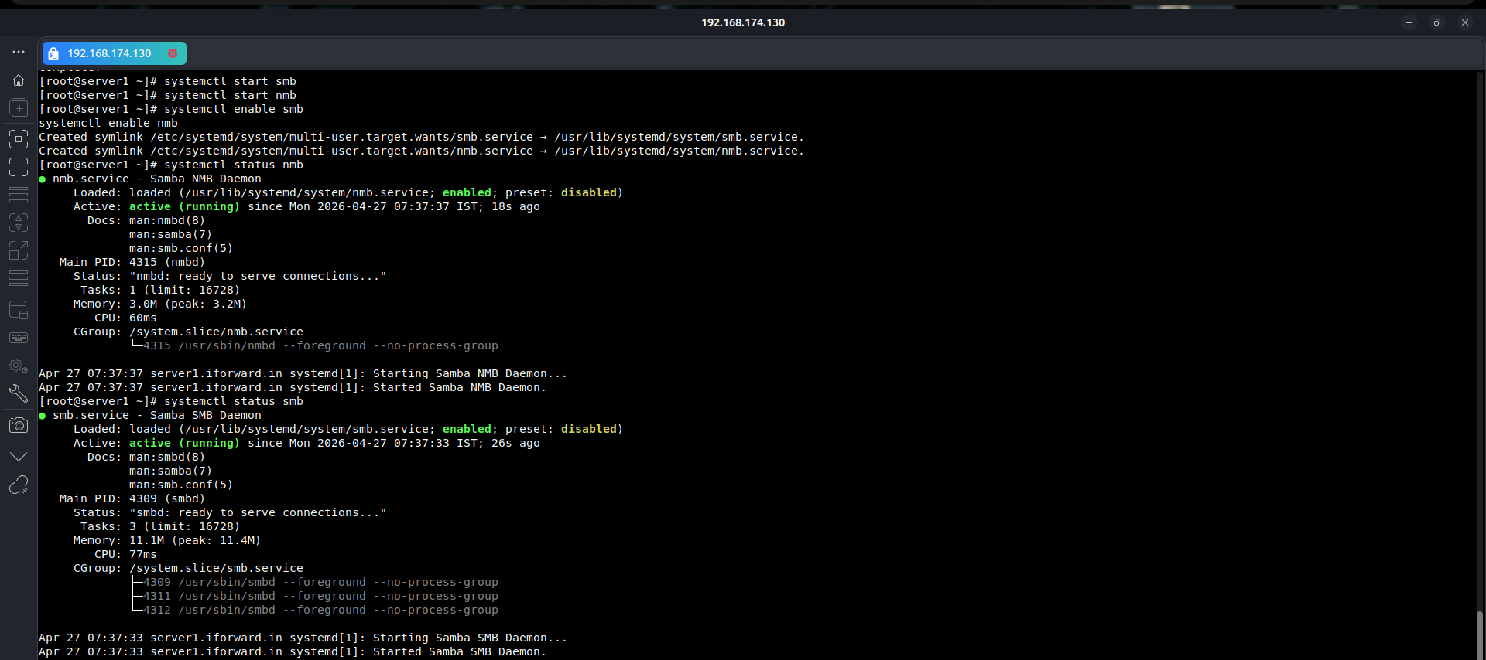
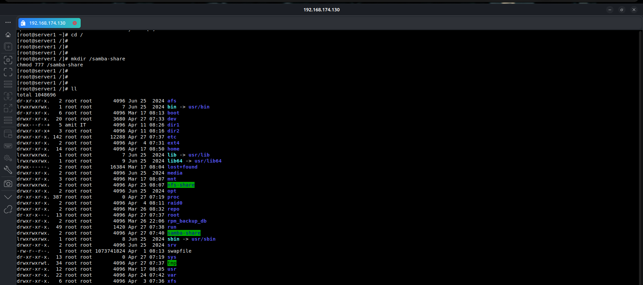

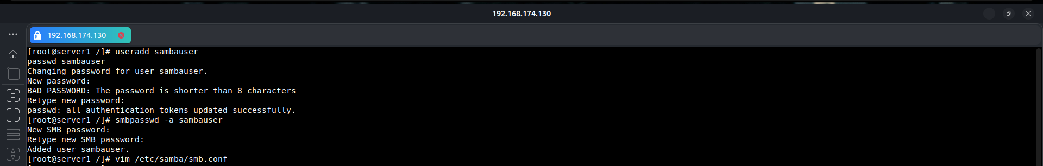
[samba-share]
path = /samba-share
comment = This Is Samba Share Server
writable = yes
guest ok = no
Linux to Window Verification:
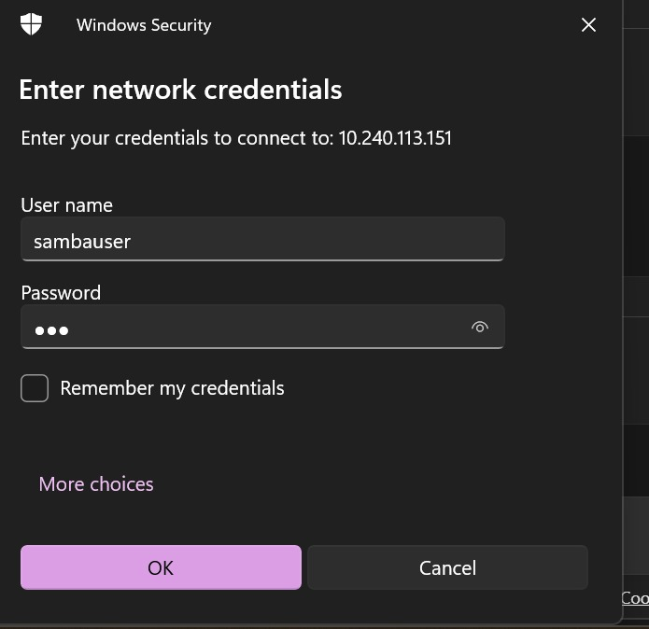
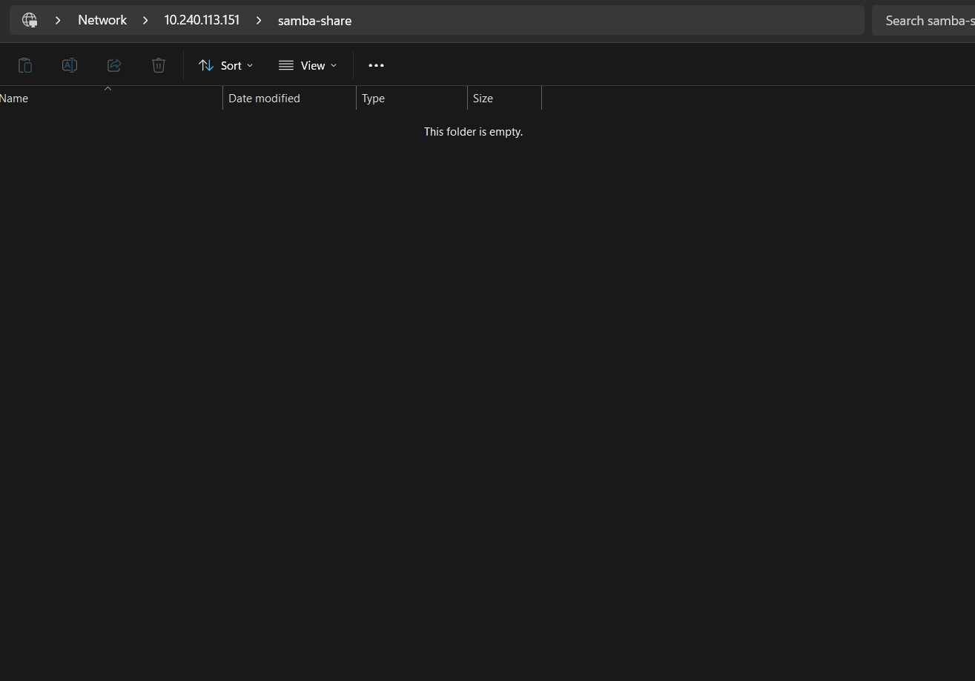
linux to linux Verification:
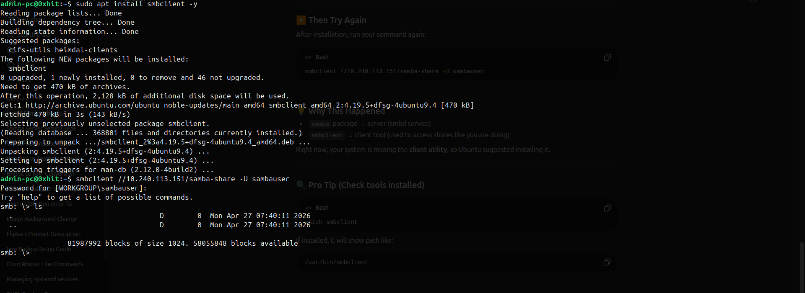
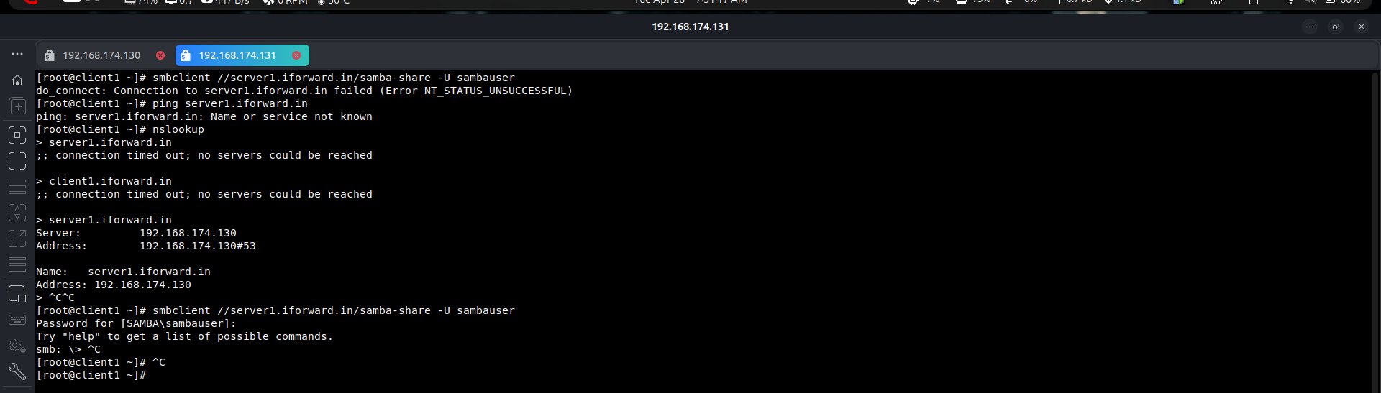
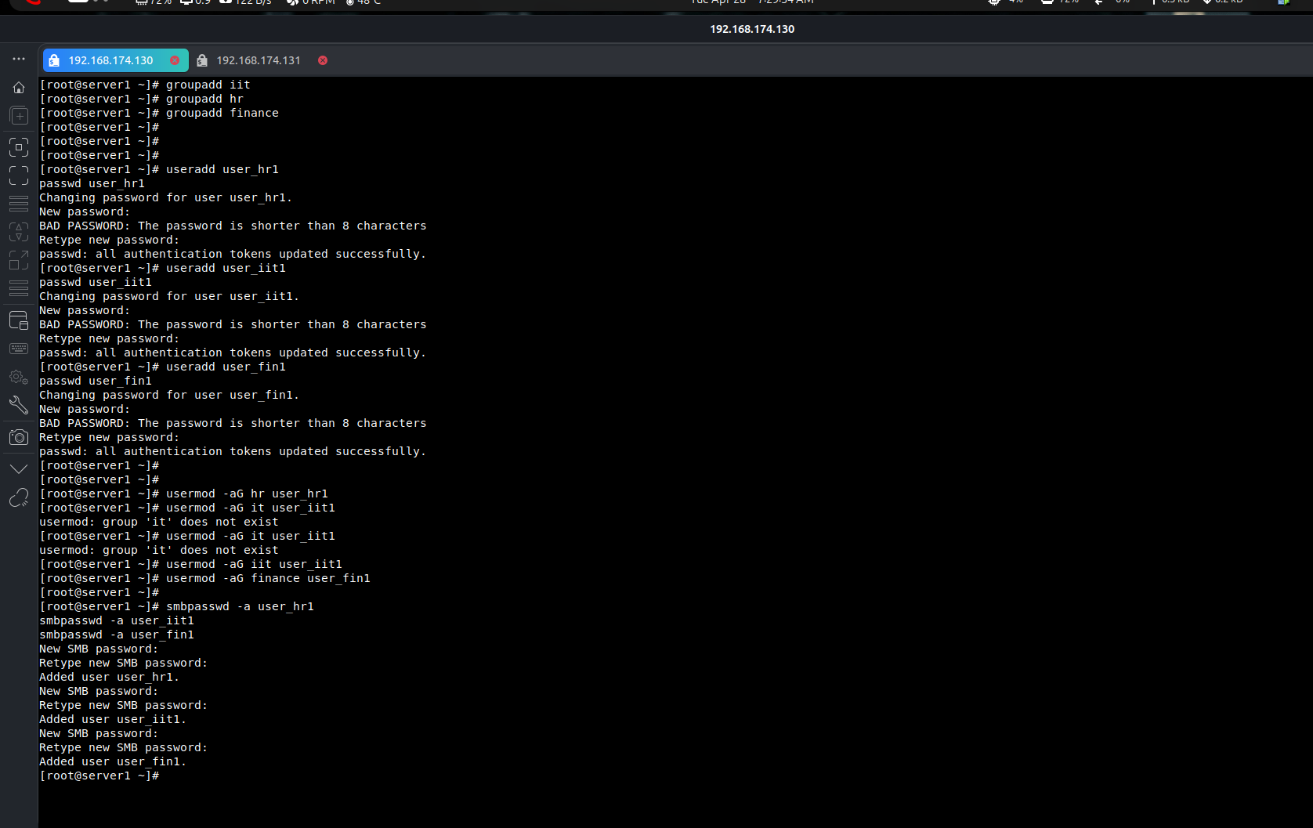

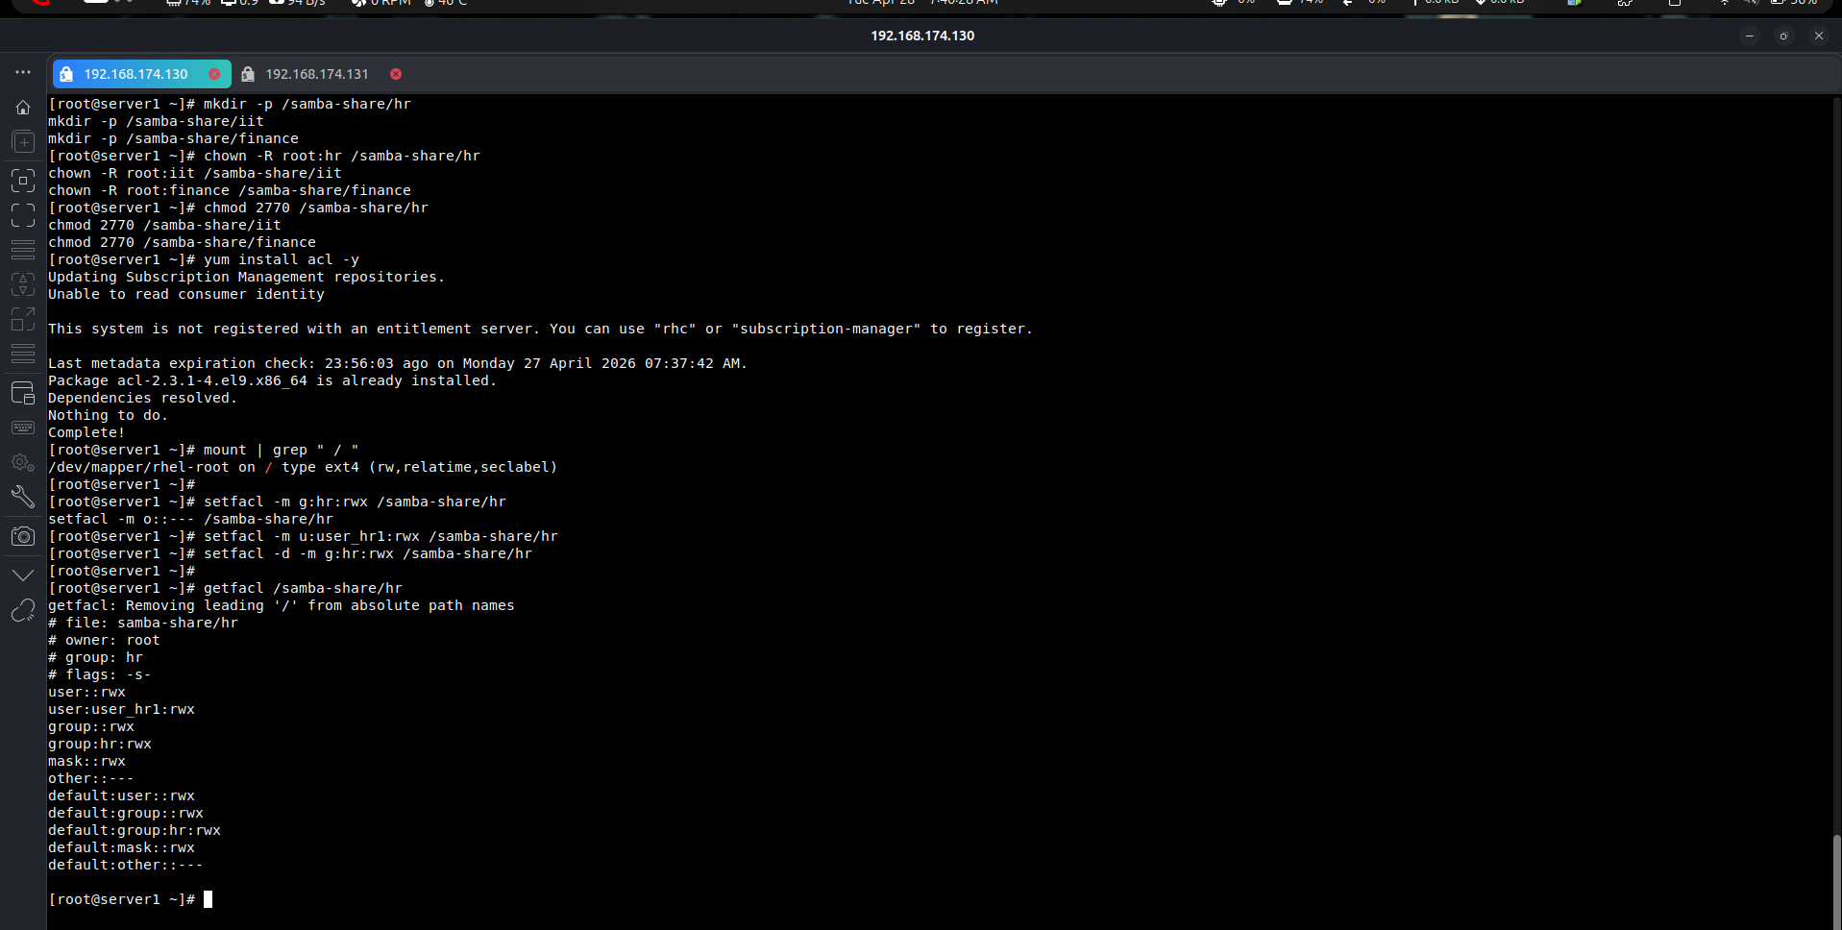

vi /etc/samba/smb.conf

[hr]
path = /samba-share/hr
valid users = @hr
writable = yes
browseable = yes
create mask = 0770
directory mask = 2770

[iit]
path = /samba-share/iit
valid users = @iit
writable = yes
browseable = yes
create mask = 0770
directory mask = 2770

[finance]
path = /samba-share/finance
valid users = @finance
writable = yes
browseable = yes
create mask = 0770
directory mask = 2770

Verification HR:
